**GRANGE REVIEWERS MEETING**

**7th January 2020**

**Meeting**

**Welcome and introductions**

**Attendees**

* **Martin**
* **Noelle**
* **Cath**
* **Dav**
* **Nicola**
* **Sue**
* **Winifred**
* **Mamoona**
* **Mathew –NHS digital**

**Apologies**

* **Adrian**

**Actions from previous minutes**

* To look at trial of MJOG – MJOG is a text message system separate to what we use at the moment. It allows patients to reply to the text message which means that patients can cancel appointments via text. Dav explained we have not managed to look into this yet. Noelle commented that there are a lot of complaints about the phone system and patient not being able to get through so this would really help patients.
* Adrian asked if diabetic appointments get a text reminder. Dav explained that text reminders go out for all appointments. Diabetic patients are now recalled by text and they then need to ring and book an appointment.
* Lisa to devise a leaflet explaining how the appointments system works and then run it by the patient group to see if they understand it first. Dav has made a start on this and handed a sheet out for them to take away. Please send any comments to Nicola, this will be used to create a leaflet.
* Patient group notice board – please send any ideas to Nicola so that she can share with the rest of the group to see what their thoughts are. It was suggested that the minutes from the previous meeting be put on the notice board.

**Action – Nicola to put the minutes on the notice board.**

**Action - Matt from NHS Digital is going to send Dav a poster on the NHS app so that it can go on the notice board.**

* Phone Company – we are looking at getting a new phone system from a new company (to be discussed later in the meeting).
* Review the statistics for the first year of the extended access.

**Action - Nicola to e-mail this out to everyone.**

* Dav to provide information on how many calls are taken during the lunchtime period when we there is no phone access and if the calls were appropriate or not. Dav explained that we were receiving on average between one and four calls every day and they are not medically urgent. Ruth is running some reports to monitor phone calls, and to look at who is on the phone and how long the average calls last.

**Action – Dav to feedback at the next meeting.**

**PCN (Primary Care Network)**

We had a meeting today and they discussed the new services which are coming out. Dav explained that funding comes in at network level as opposed to coming directly the surgery.

Social prescribing is a new service, this will look at frequent attenders and funding has been provided for this.

We have also been given funding for winter pressures. This will free up clinicians to go out and do late visits. We have been given funding for 15 ANP hours each week. Unfortunately this has created a bit of a free for all as everyone is trying to get ANPs all from the same pot.

Community links will be offering a session at the Grange, it is planned for Wednesdays weekly.

Winifred explained that she helps run a group called Elderberry Club, it costs approximately £3 a month, and they can collect people and bring them to the club. Winfred explained that they are struggling to get people to join even though she keeps hearing that people are lonely. Winfred is going to bring a leaflet in to go on the notice board.

**Staff updates and recruitment**

* Lisa, reception team leader, left just before Christmas and has gone to another practice doing a different role. We had two staff members, Lisa and Kelly, who were at the same level and Kelly is now the admin team leader.
* Dav explained that we have lost approximately nine staff members over the last six months from a variety of different roles, ANPs, admin, nurses and business manager. This is due to changes in the practice and the way we are working, not everyone is comfortable with change. We are looking to replace the ANPs in the short term (6 months). We have four GPs who will be retiring in the next two years and we will struggle to recruit (national problem) so change is needed. We are still trying to recruit.
* New admin members - Alesha and Aneela, with one more starting on the 20th January and two more offers out at the moment.
* Alan (advanced nurse practitioner) is leaving at the end of January 2020. There is an advert out at the moment for advanced nurse practitioners and GPs.
* HCA apprentice, Donovan is now in post and will be training for the next two years.
* Two new nurses – Gurjit and Simran who are being trained at the moment and working through courses.
* Martin suggested that we need to keep the website up to date and keep patients aware of the changes.

Action – to update the website regarding changes to how our systems and processes work (appointment system).

* Dr Kumars approach to GPs running late is for patients to either rebooked, to come back later or to have a telephone call instead.

**Phone update**

We acknowledge that the current phone system is not fit for purpose, however the phone company does not agree and they want £5,500 from us to come out of the contract. We are forced to take drastic action due to the level of patient complaints. Dav has a call with the director of the phone company this week and we are looking into a new phone provider which is all cloud based. The new phone system will tell patients how many phone calls there are in the queue. Dav explained that originally we had three phone companies pitch. Noelle explained that while she has been doing the Friends and Family Test the phone system is the biggest issue amongst patients so feels that we need to publicise this to the patients and make them aware. Another complaint is patients coming down at 8am for an appointment, this causes issues among the patients and a ticket number system would help.

Dav explained that sometimes staff put the volume on their phone to silent which means staff do not always see the lights flashing on the phone to indicate a call is coming through. This would explain why patients are complaining that they are ringing and not getting answered. This is being monitored now.

**Action – put a message on the TV screen explaining that we are getting a new phone system.**

**Appointment capacity review - update**

We are now looking at appointments four to six weeks ahead and aim to have at least 100 appointments open for booking each day. If we are not achieving this then we will try to get locums in.

**Extended access update**

Dav explained that we are still taking part in the extended access scheme. We offer appointments on a Tuesday or Wednesday every week from 6.30-8.30pm and on a Saturday 8.30-12.30pm. This going well and we submit figures to My Health Huddersfield once a month. Appointments can also be booked via the central hub at Huddersfield Royal Infirmary and appointments are available 6.30-8.30pm Monday-Friday and 10am-2pm Saturday and Sunday.

**Keldregate update**

Dav explained that the new GP partner feels that Keldregate is not fit for purpose plus we have had an independent report done which also states the same. To reduce risk we have reduced the opening hours at Keldregate. It is now open every morning. There has been no reduction in clinics or capacity and the same types of appointments are available there. Discussions have taken place with the CCG regarding closing the surgery.

**Action – keep the patient group informed.**

**Community Ultrasound at GGP**

Community ultrasound is now available at the practice one day a month. At the moment we are justseeing our own patients and the plan is to have it available every day of the week.

**Name Change – Grange Medical Practice**

Dav explained that we had an away day in June, we talked about a possible name change and Dr Kumar has decided that the new name will go ahead. The patient group was concerned as to how much will this cost and could the money be better spent elsewhere.

**Action – order chairs for the waiting room with arms for elderly patients.**

**Catch it, bin it, kill it campaign – information to go in the waiting room in due course.**

**Jo’s Cervical Cancer Trust Awareness Week 20- 26th January**

If Noelle or Winifred is in surgery doing Friends and Family tests that week then can they please promote it? The rates for cervical screening in the practice is good, however bowel screening and breast screening are not so good and we need the patient group to promote this.

**Online access update**

This has been promoted through the network and we now have a banner in the waiting room promoting this.

From January to now we have gone up from 22% to 30% and percentage wise we have increase in the amount of online prescriptions. As a network we have increased from 28% to 33%.

Matt explained that some surgery have digital access days where they have a digital expert on hand to go through the process with patients. Another suggestion was that a member of staff rings the patient a week after they have signed up to check whether they have logged in and if everything is okay.

**Edenbridge Apex – in-house intelligence reporting**

This is fairly new to us and we have a training day booked in for this. We can look at a number of things, including the list size and how many patients left the practice etc.

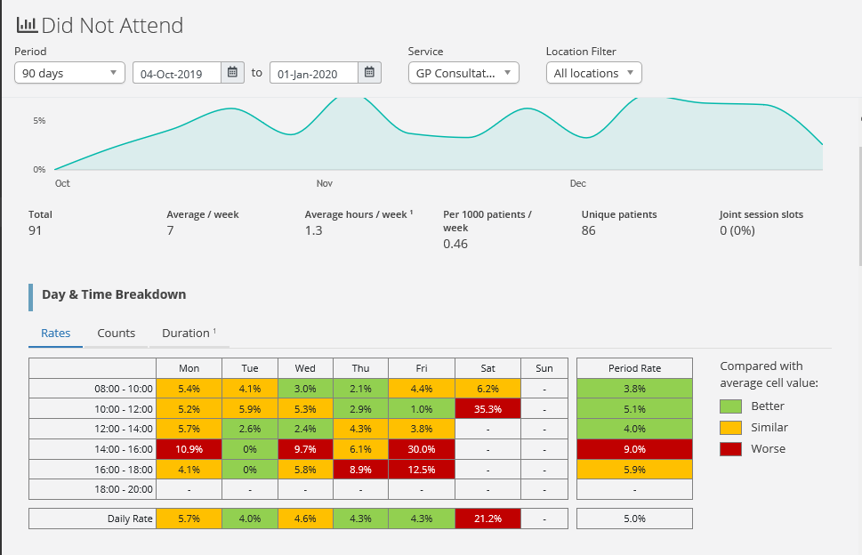

Dav explained that we can do some work on the DNA’s and why we are worse on a Friday between 2-6pm and the different appointment types.

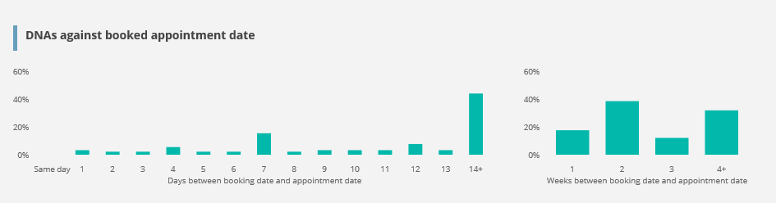

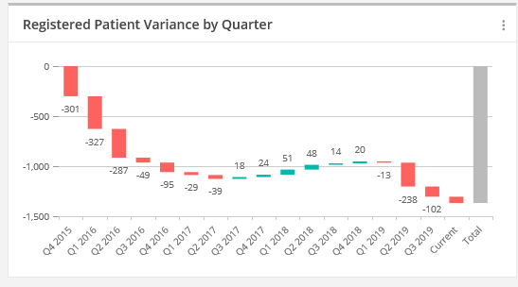

**NHS App**

Matt, a researcher for NHS Digital in Leeds has come to the meeting to talk about the new NHS app. He explained that they deal with lots of data issues, for example, e-referrals, NHS choices etc.

At the moment he is doing work with the NHS app, this is the NHS version of booking appointments, prescriptions and communication via the app. Matt explained that hospitals will hopefully be coming on board in the next 12-24 months.

In order to access and log in to the NHS app you need to proof who you are. The first time you try to access it you will need to provide a series of information to prove you are who you are, this is due to the sensitive information held. You can assess the app via any app store or via the internet. To prove who you are you will need to have a driving license or passport; the app will take a photo and a short video of you. Alternatively if you have system online then you can use this information and the GP surgery can verify the patient’s identity. The age range for this app is over 16 years.

Other services – text, digital version of growth book for children, along with another 15 services coming in over the next 12 months.

Matt is going to come in and do some training with the reception staff so they can explain to patients what the app is about and how to promote it efficiently to patients.

**AOB**

CCG are in the process signing up for a package called E-consult which is a triage system. When it goes live, which is hopefully in March, all of the on the day appointments are booked through this and if it cannot be done through this then the reception staff will assist patients.

**Date of next meetings:**

* **7th April 2020**
* **7th July 2020**
* **6th October 2020**